Project 2 - part 3 - Wrapper
Hadeer Ghoneim
Verification Diploma

• Verification plan
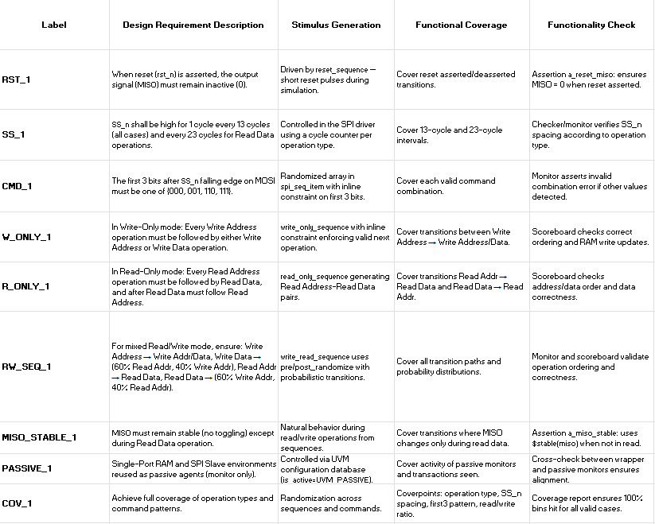

• UVM Diagram
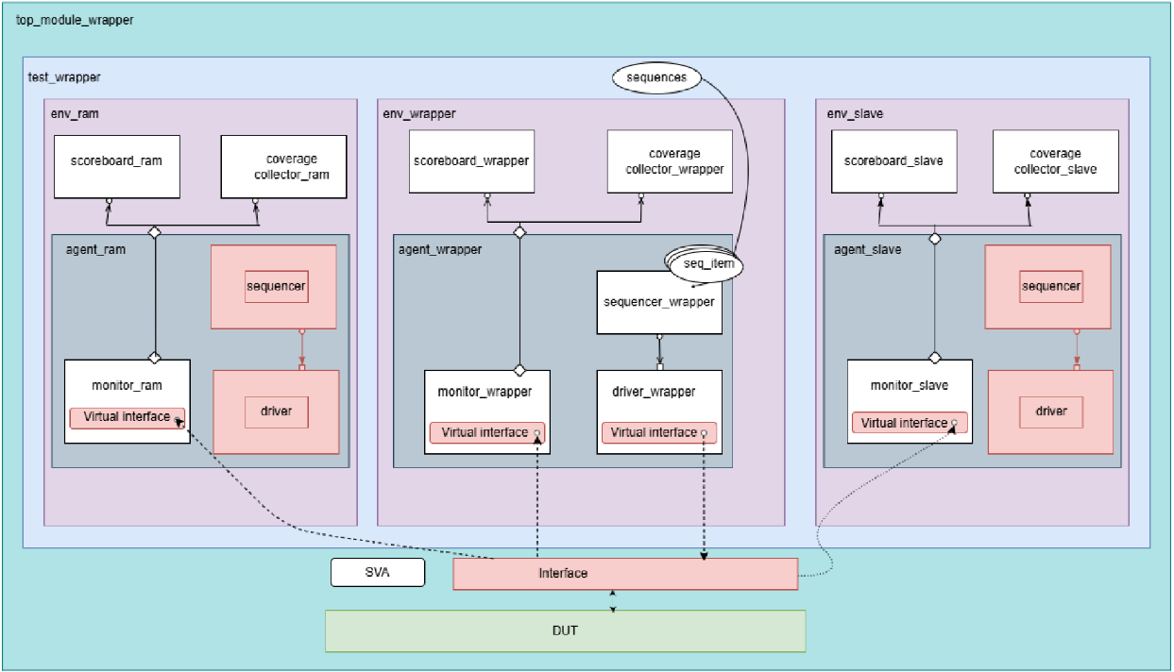

o How UVM testbench work

- Randomized Stimulus Generation
Generates protocol-compliant and corner-case SPI transactions.
- Golden Model Comparison
C-based reference model ensures cycle-accurate checking.
- Assertion-Based Verification
Validates protocol timing, FSM transitions, and data integrity.
- Coverage Analysis
  - Functional Coverage: SPI states, RAM operations, and cross-coverage
  - Code Coverage: line, branch, expression
  - Assertion Coverage: protocol timing checks

UVM Testbench Architecture

Env → UVM Environment
test → UVM Testbench
agent → UVM Agent containing:
sequencer → Generates sequences
Driver → Drives stimulus to DUT
Monitor → Observes and collects transactions
Sequence → Defines test sequences for different SPI operations
Sequence item → Defines transaction-level items for SPI communication
config → Configuration settings for SPI testbench
interface → UVM Interface to connect DUT with the UVM testbench
scoreboard → Compares actual DUT output with expected results
coverage → Defines and monitors functional coverage metrics
Top → top module

• Code Coverage report, Functional Coverage report, and Sequential Domain Coverage report
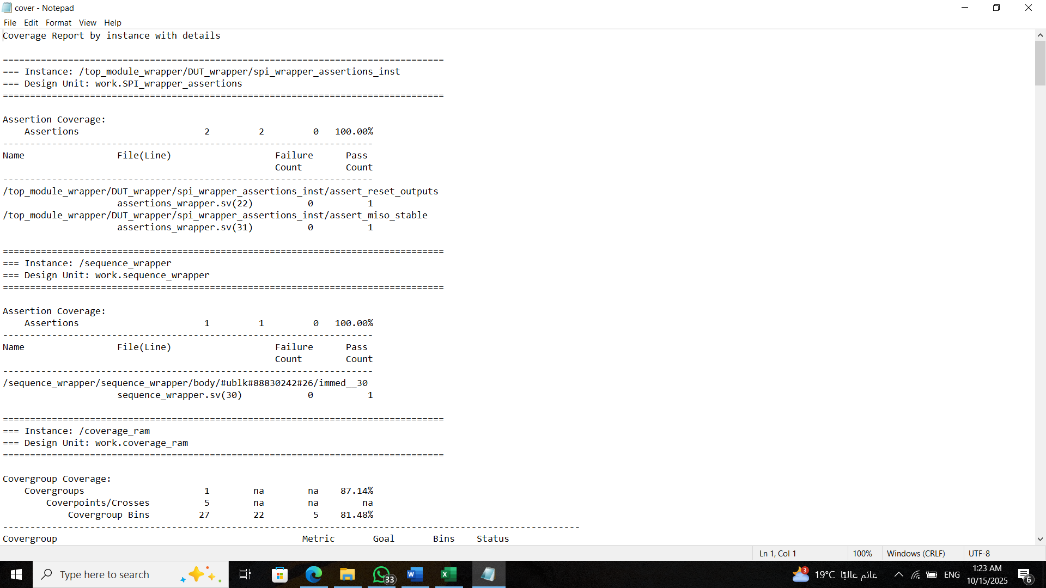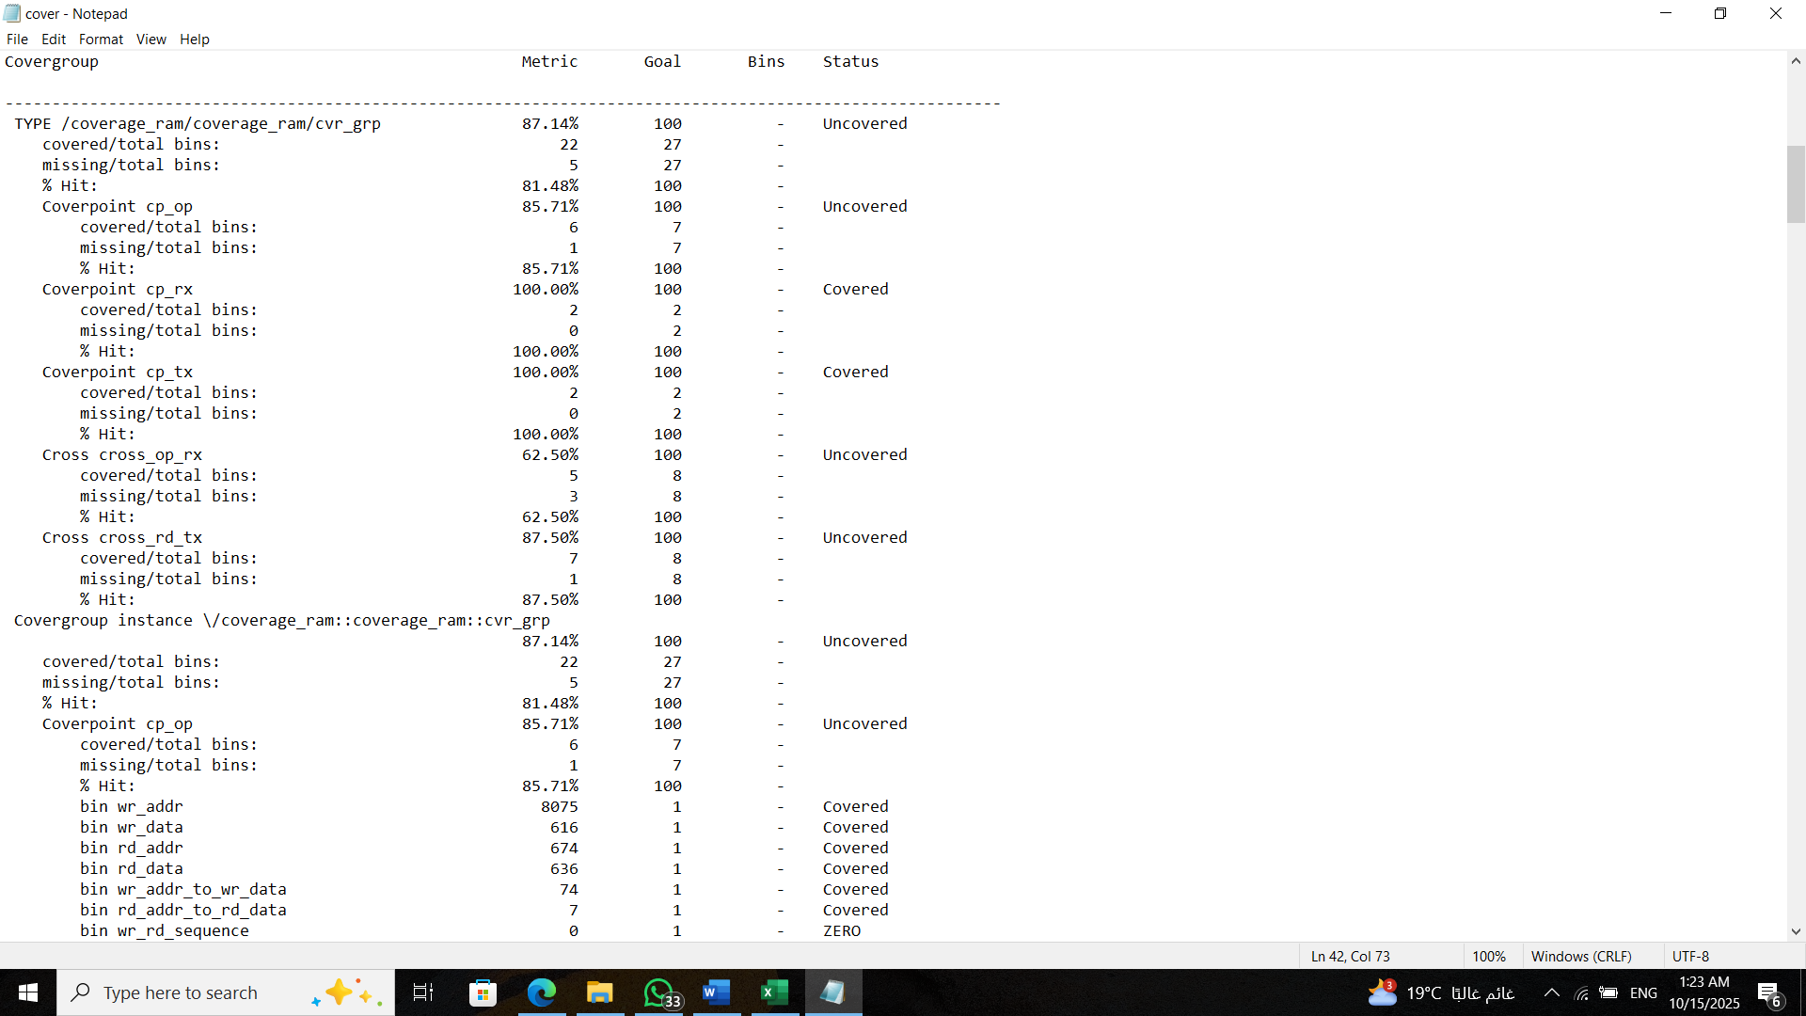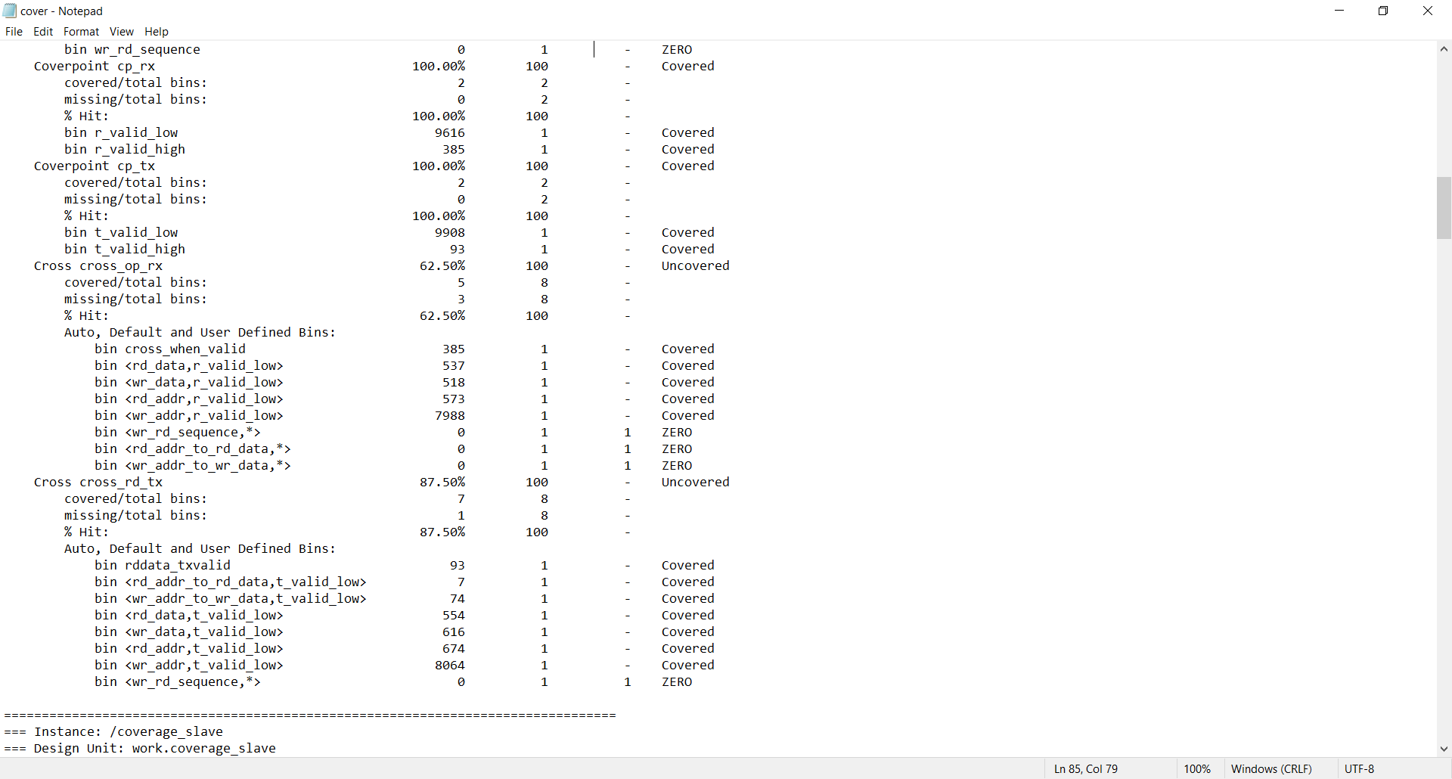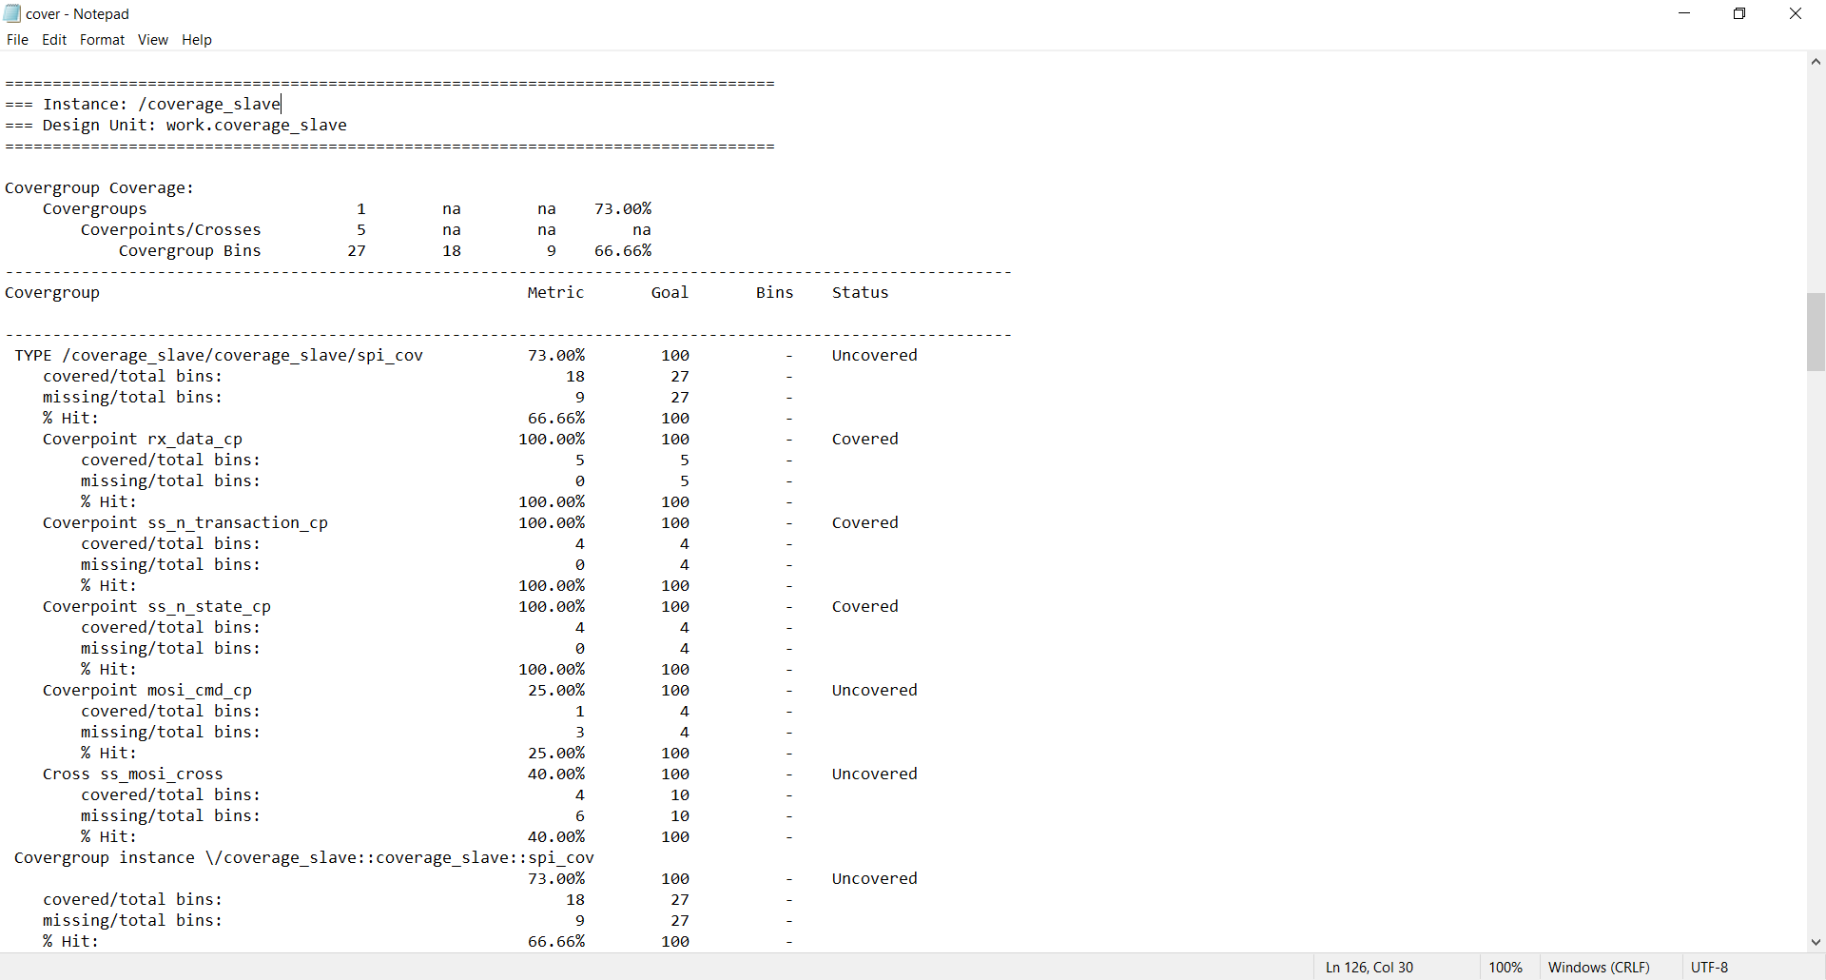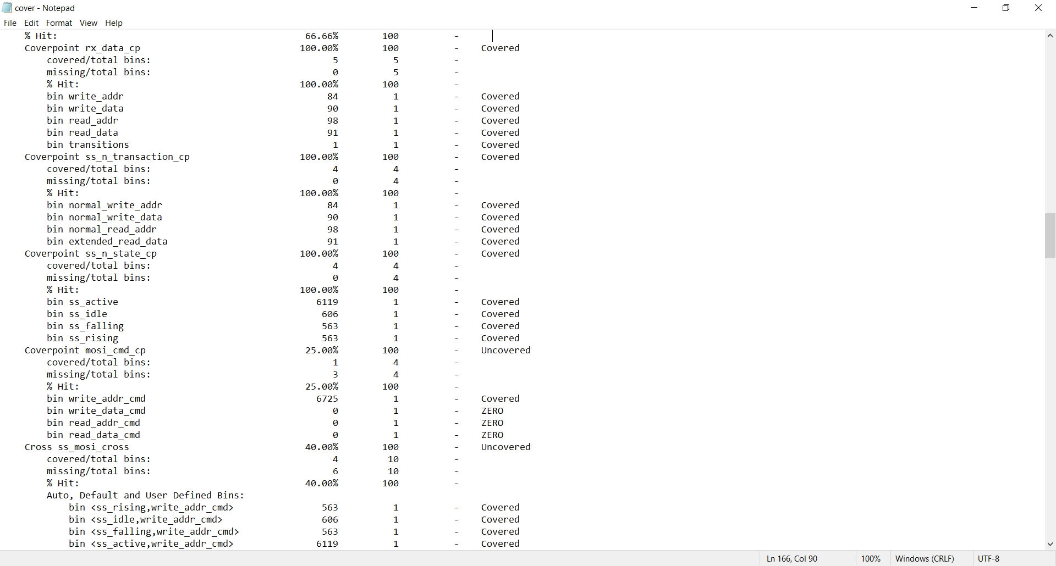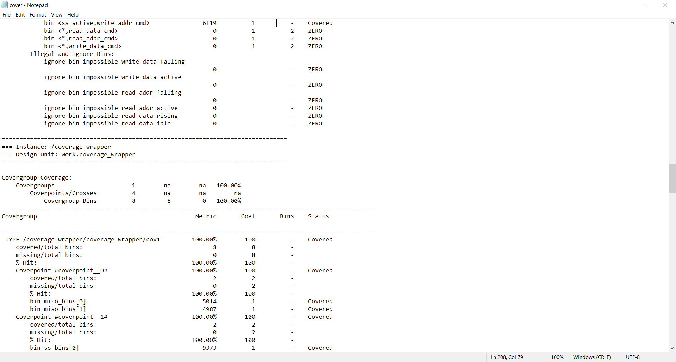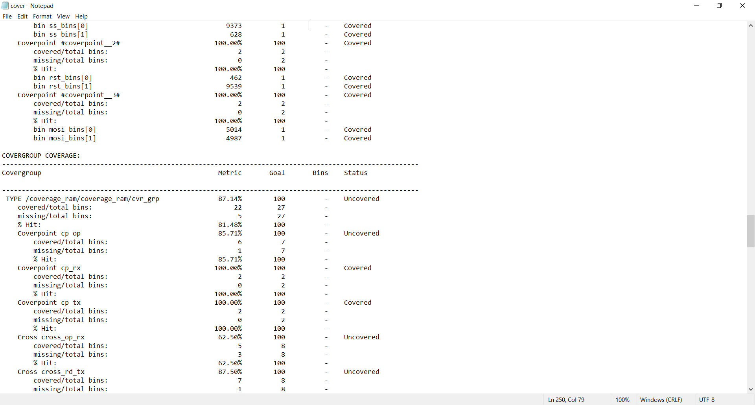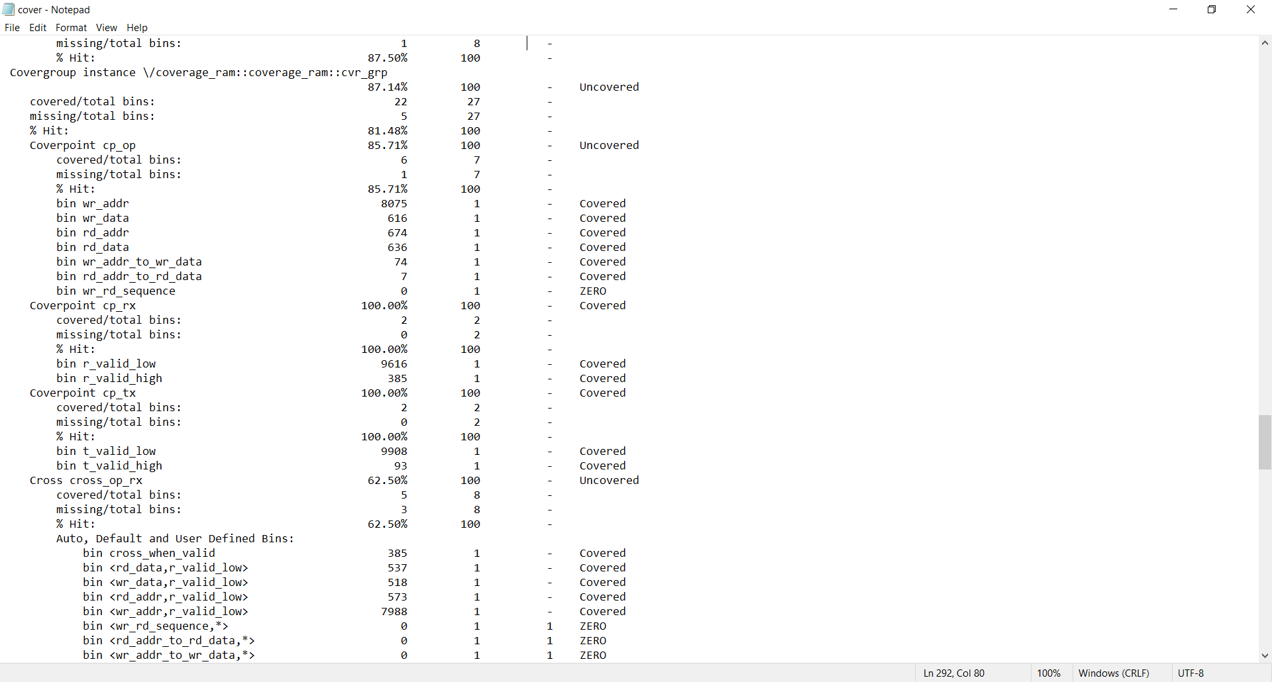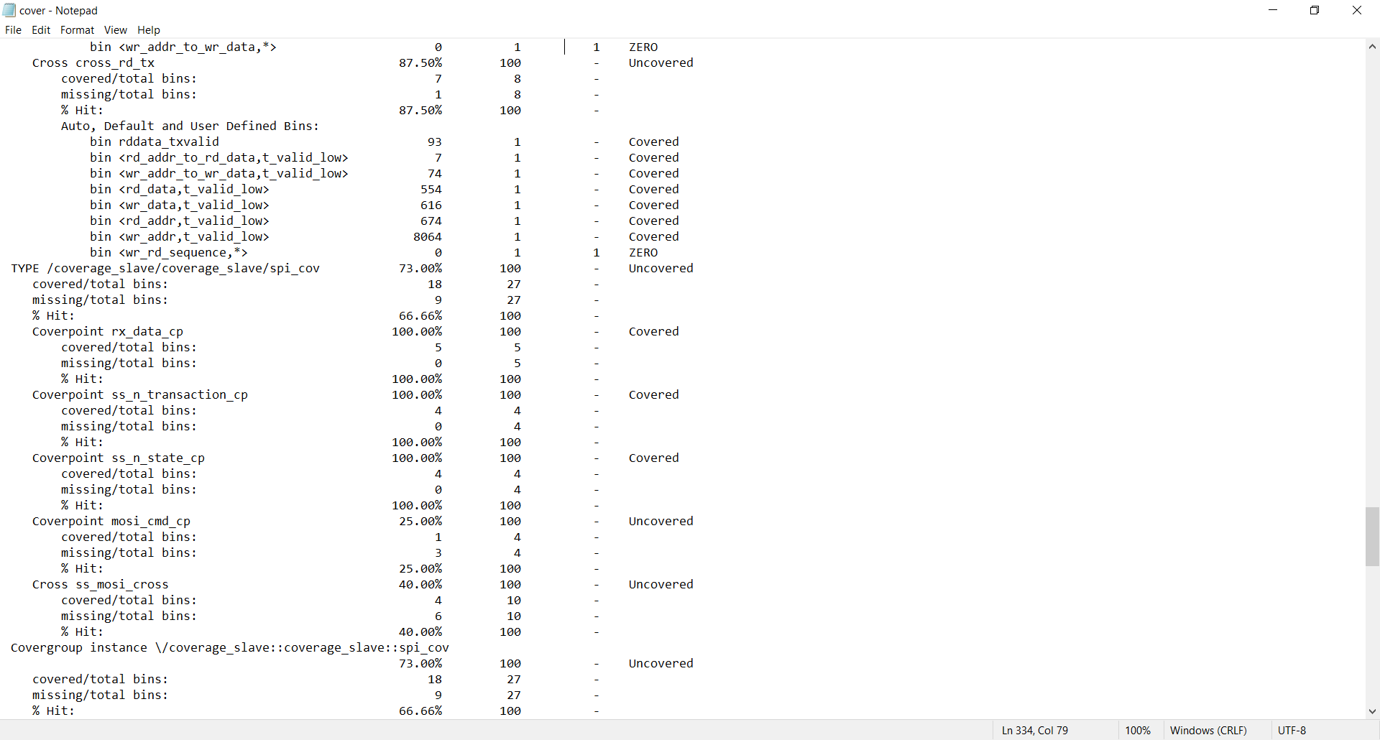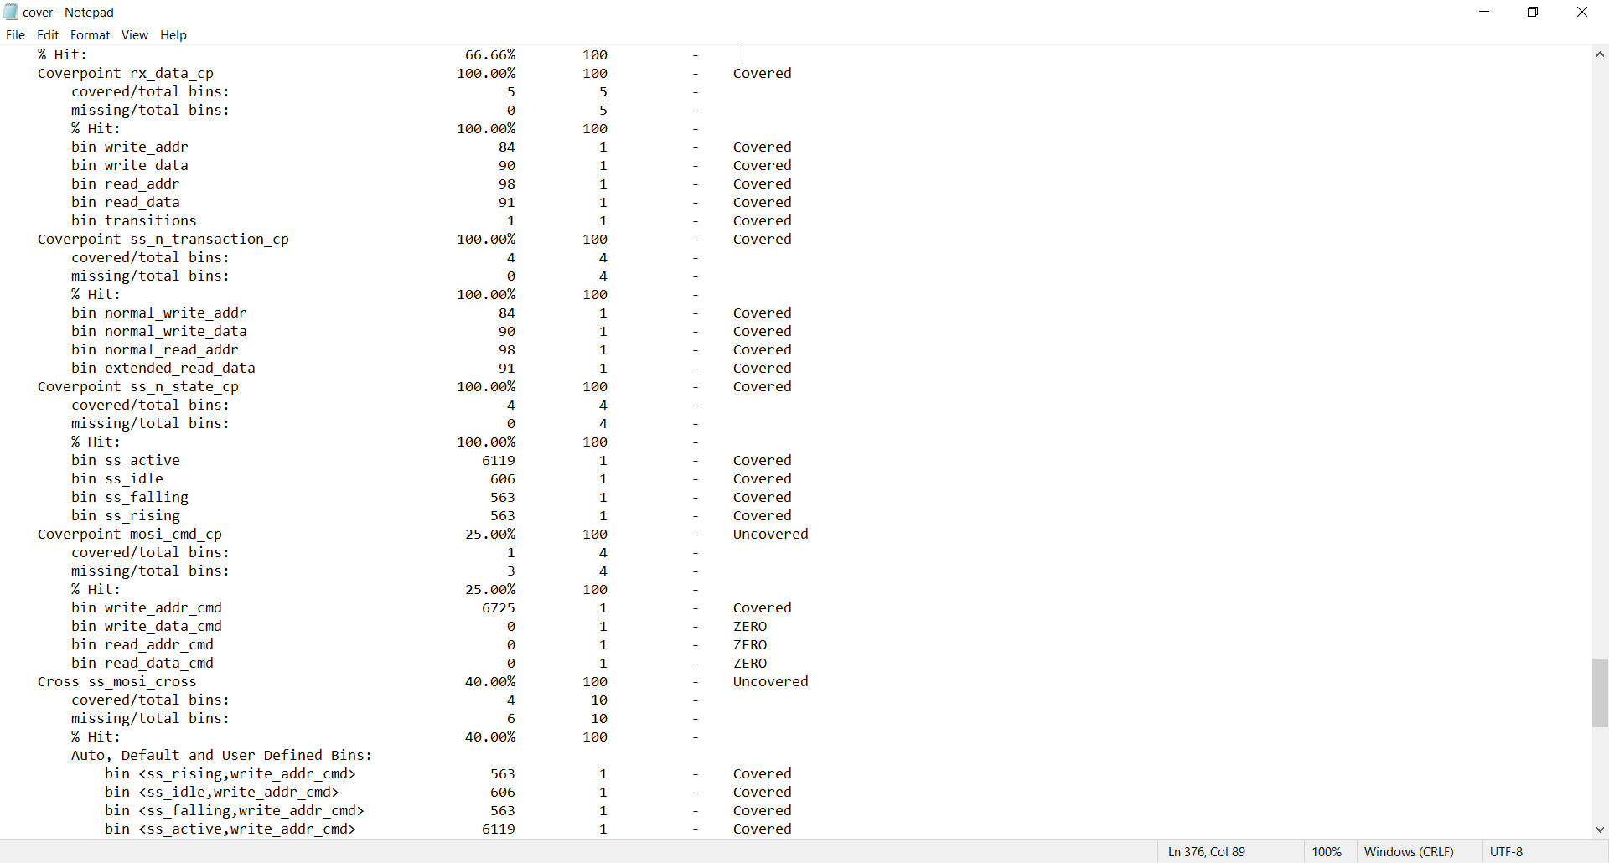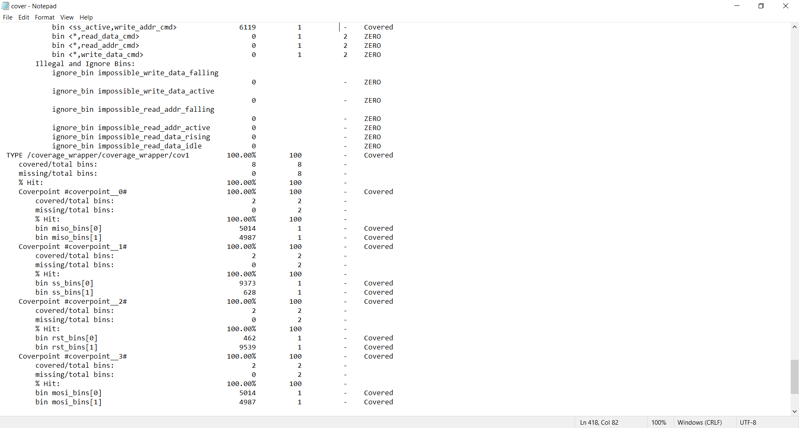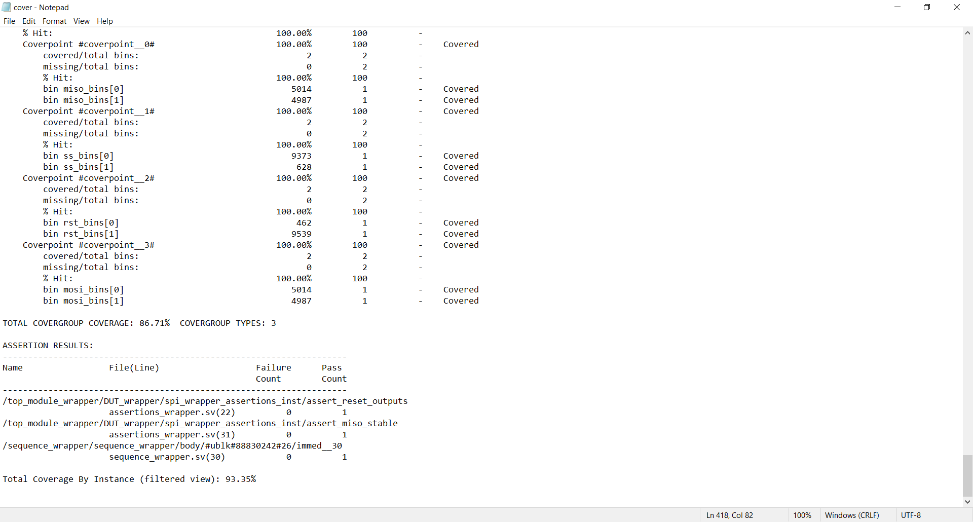
• Bug report
SPI_slave Bugs Summary:
Critical Bugs:
- State mixup: READ_ADD and READ_DATA states swapped in FSM logic
- Missing counter reset: Counter not initialized in IDLE state
- MISO timing: Transmission depends on tx_valid instead of SPI clock
- Bit width inconsistency: 8-bit vs 10-bit transfers in read operations
Solu:
Critical Fixes:
- Swap states: READ_ADD ↔ READ_DATA in CHK_CMD logic
- Initialize counter: Add counter <= 10; in IDLE state
- Fix MISO timing: Remove tx_valid dependency, transmit continuously in read states
- Standardize bit width: Use consistent 10-bit transfers throughout
Major Fixes:
- Add default case: default: ns = IDLE; in state machine
- Fix rx_valid: Clear in all states except when data is ready
- Improve flag management: Reset received_address in IDLE state
- Complete reset: Ensure all registers properly initialized
Minor Fixes:
- Use blocking assignments properly in combinational logic
- Add output register for MISO to prevent glitches
- Fix counter reset: Always reset to 10 for consistency

Wrapper bugs
Signal Width Mismatch - 10-bit rx_data connected to 8-bit RAM port
Missing RAM Address - No address extraction from 10-bit frame

• QuestaSim waveform snippets
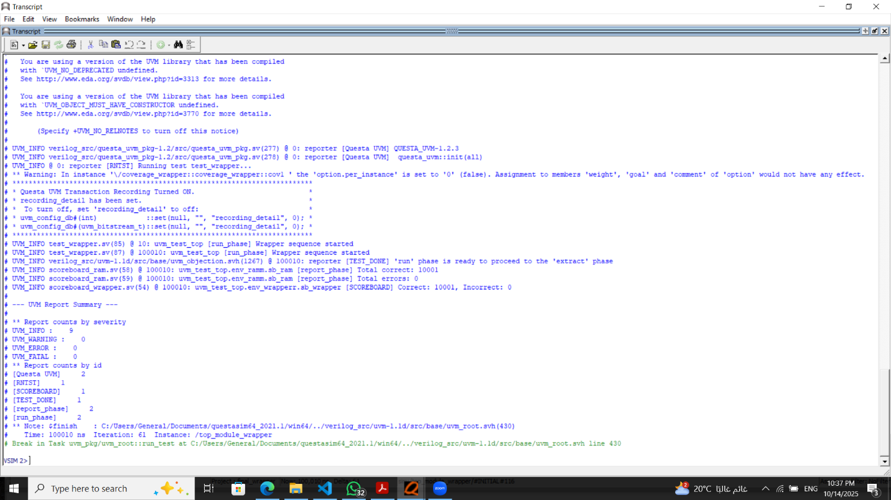
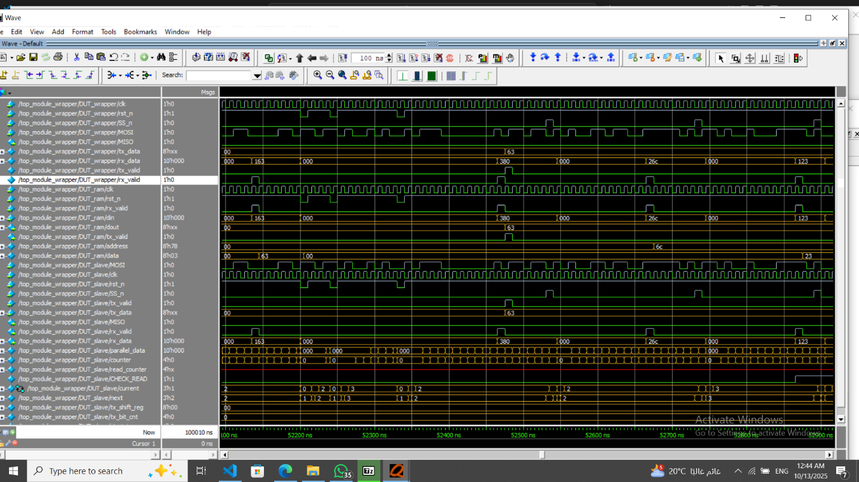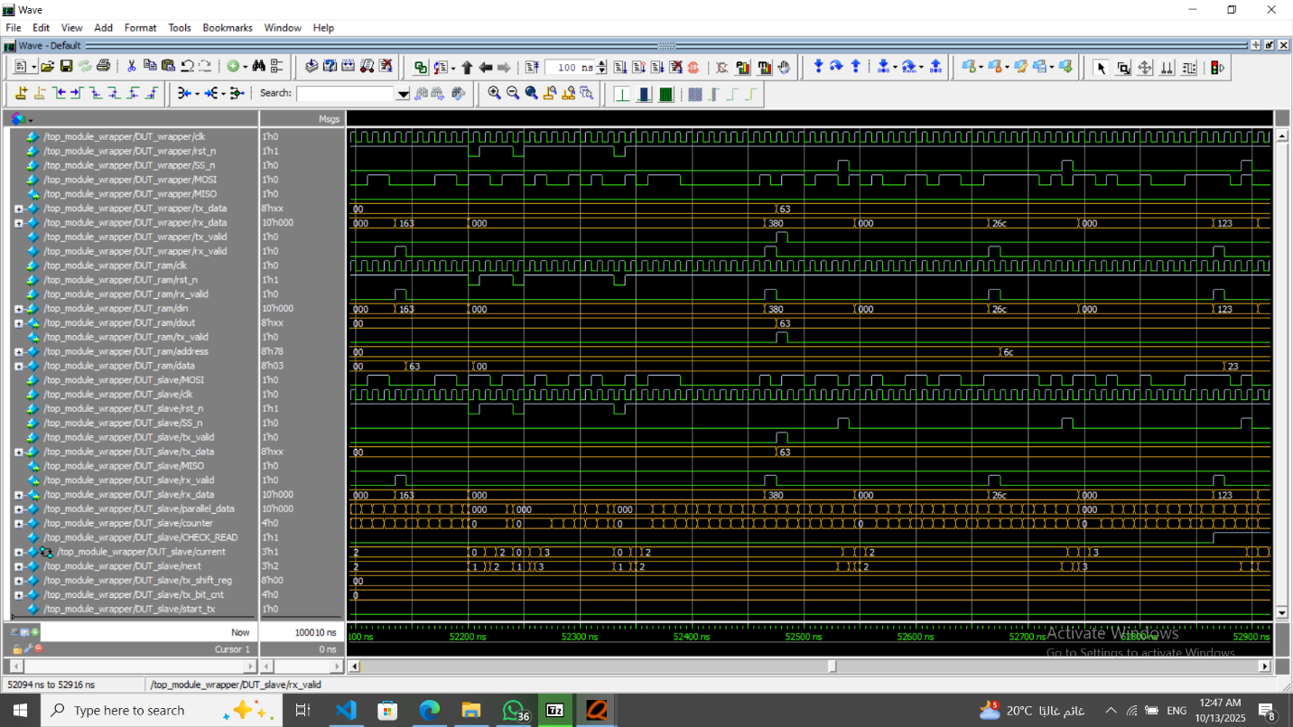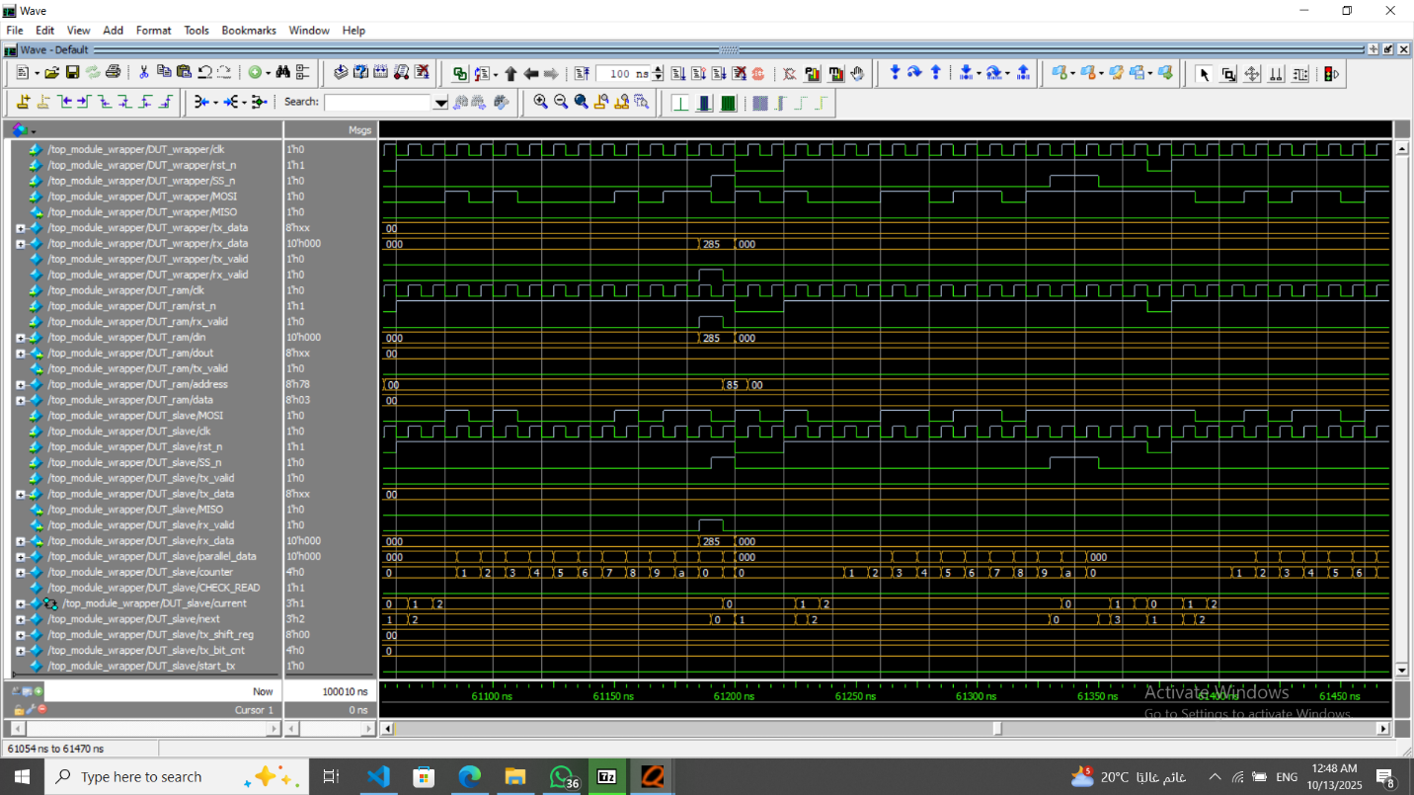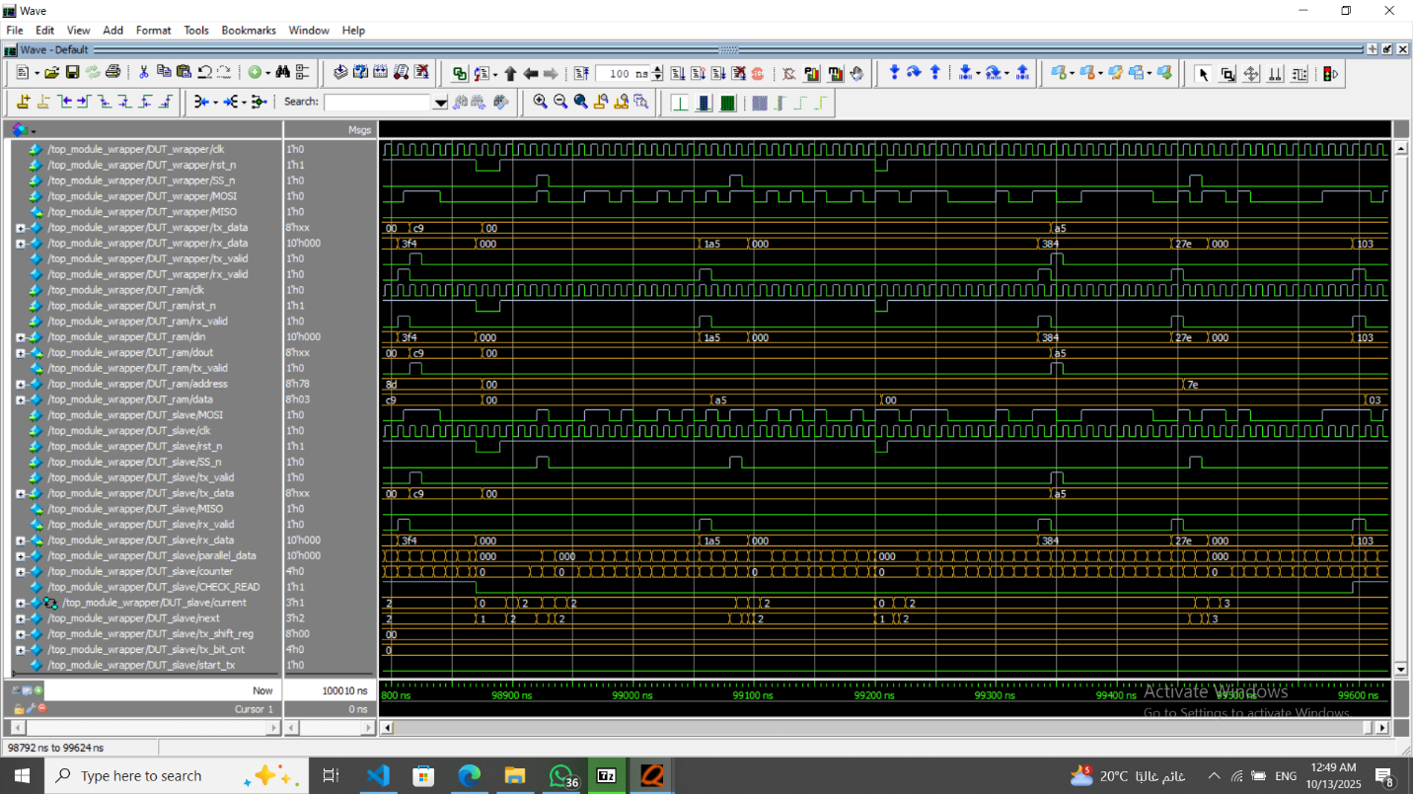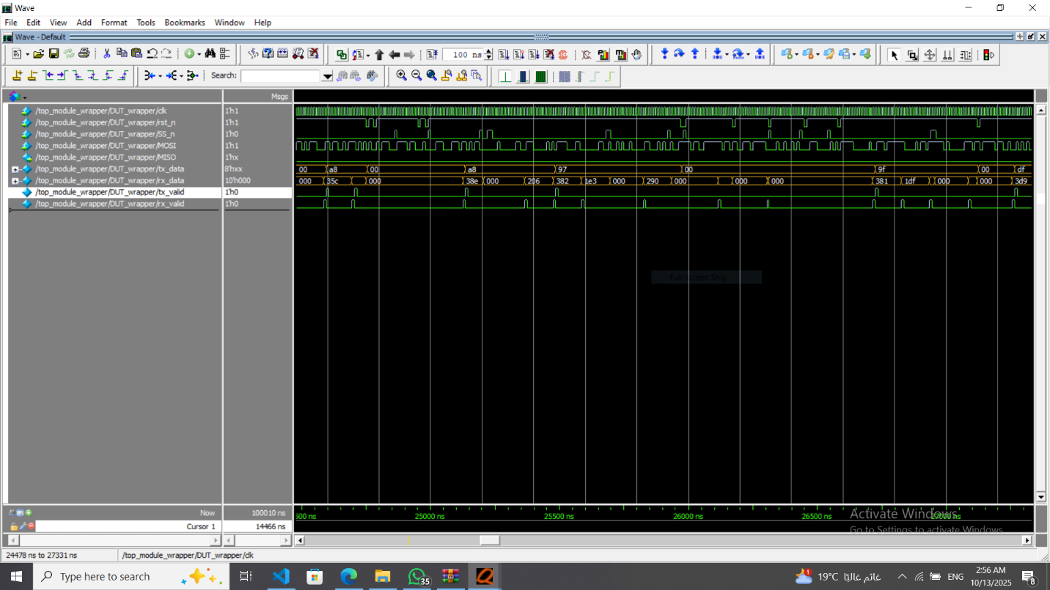
• Assertions Table
